Neeraj Appari S073

Dot Net Practical 9-18

Practical-9

Aim: Write a C# program to check given number is even or odd.

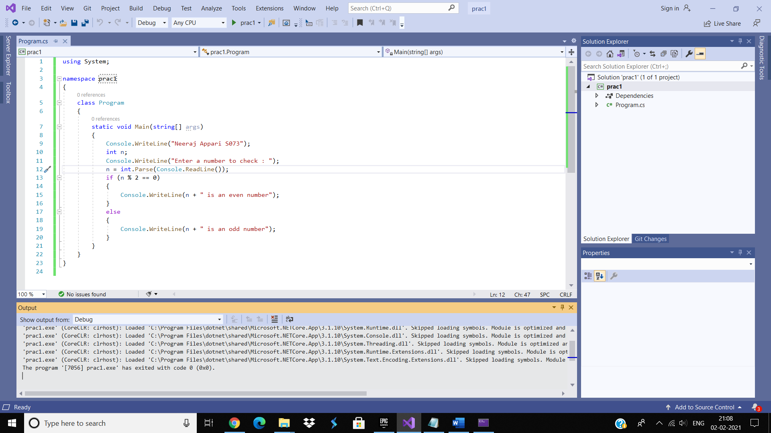

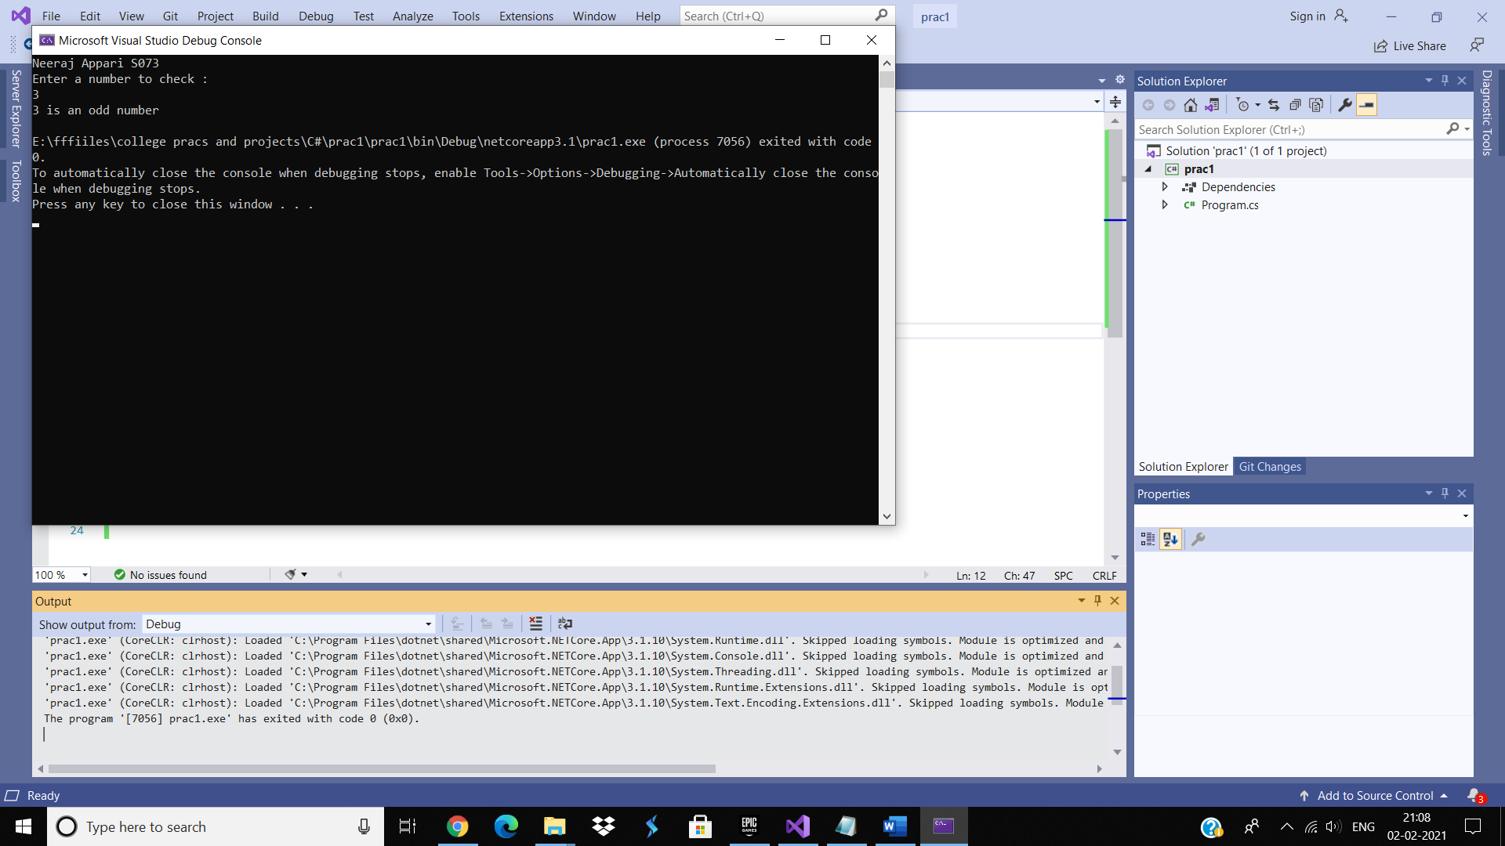

Practical-10

Aim: Write a C# program to check given number is Armstrong or not.

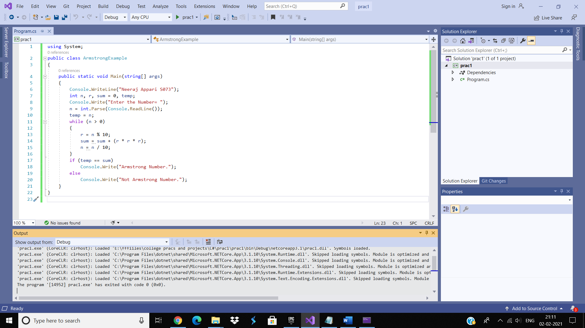

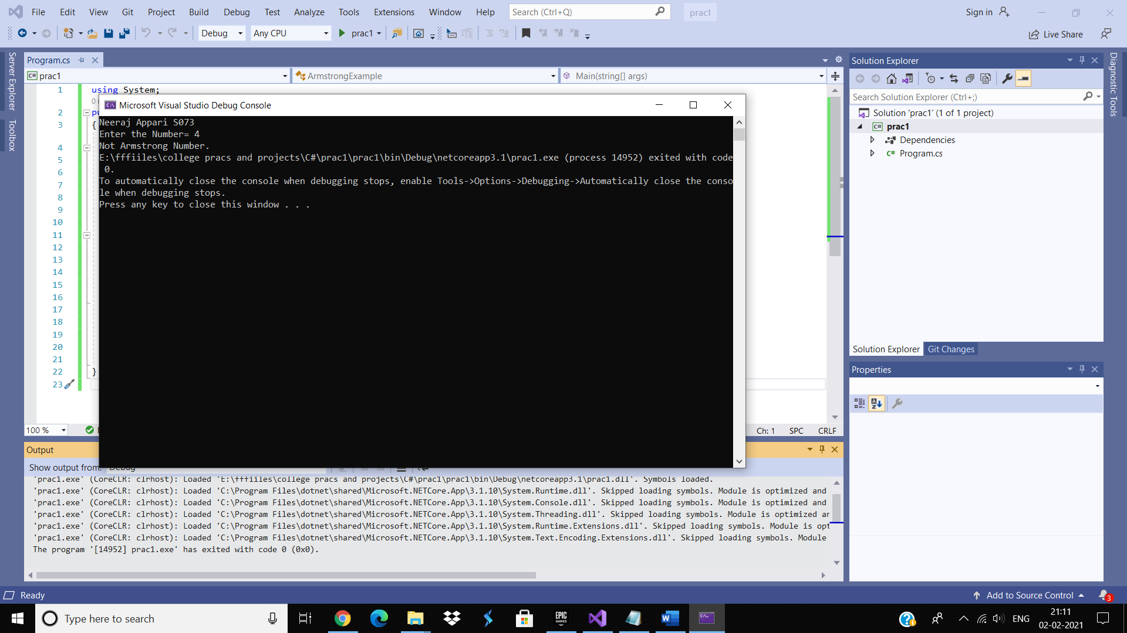

Practical-11

Aim: Write a C# program to accept no. from user and print factorial of it. (recursion)

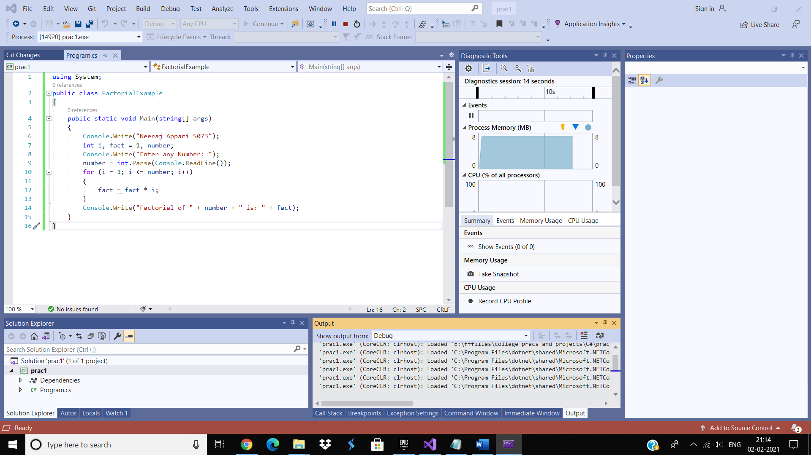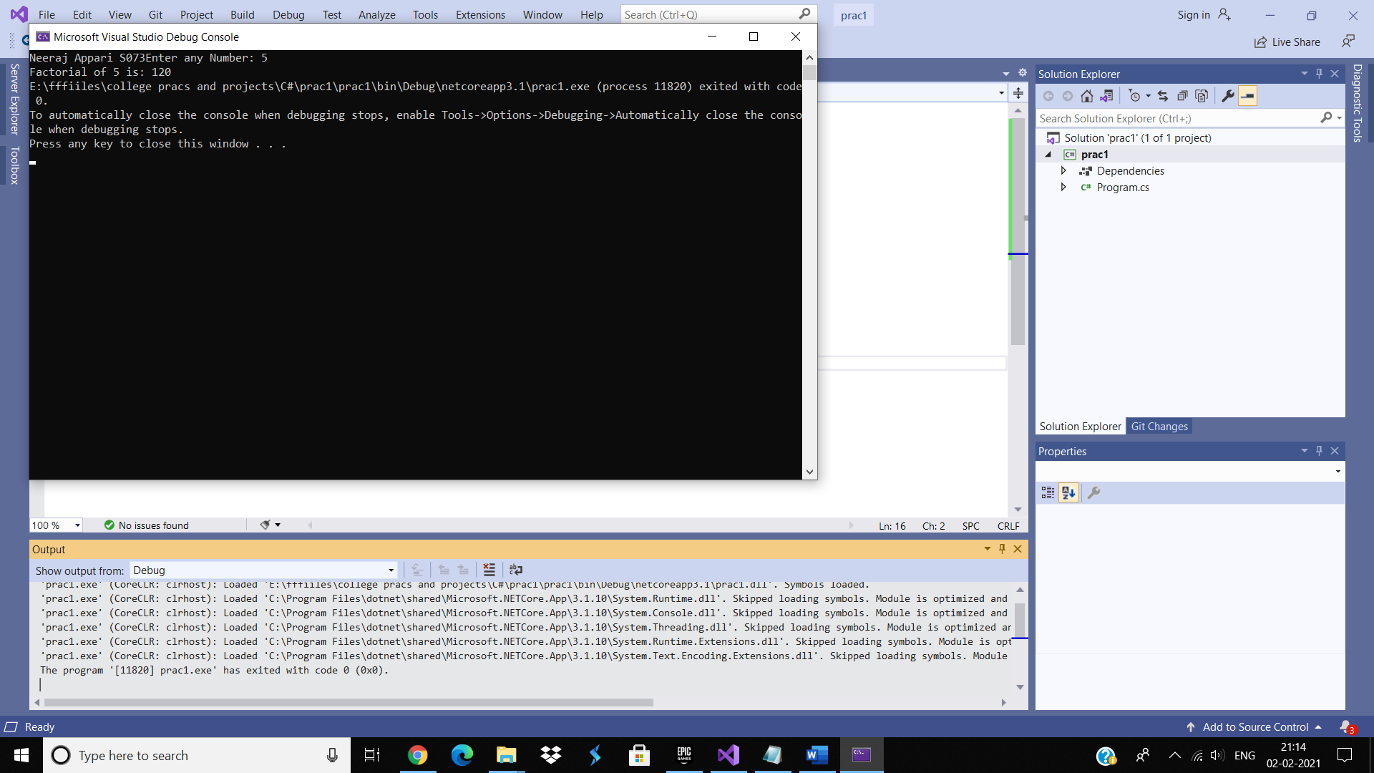

Practical-12

Aim: Write a C# program to check given number is prime or not.

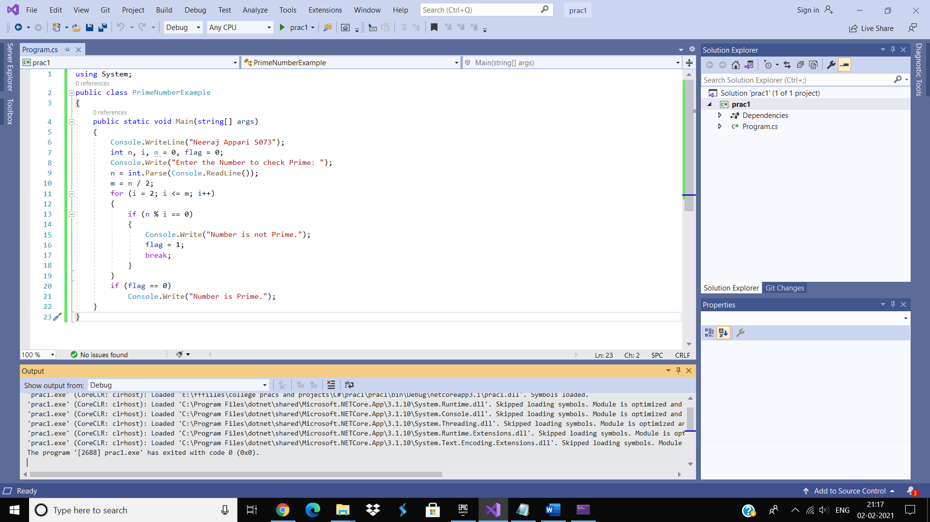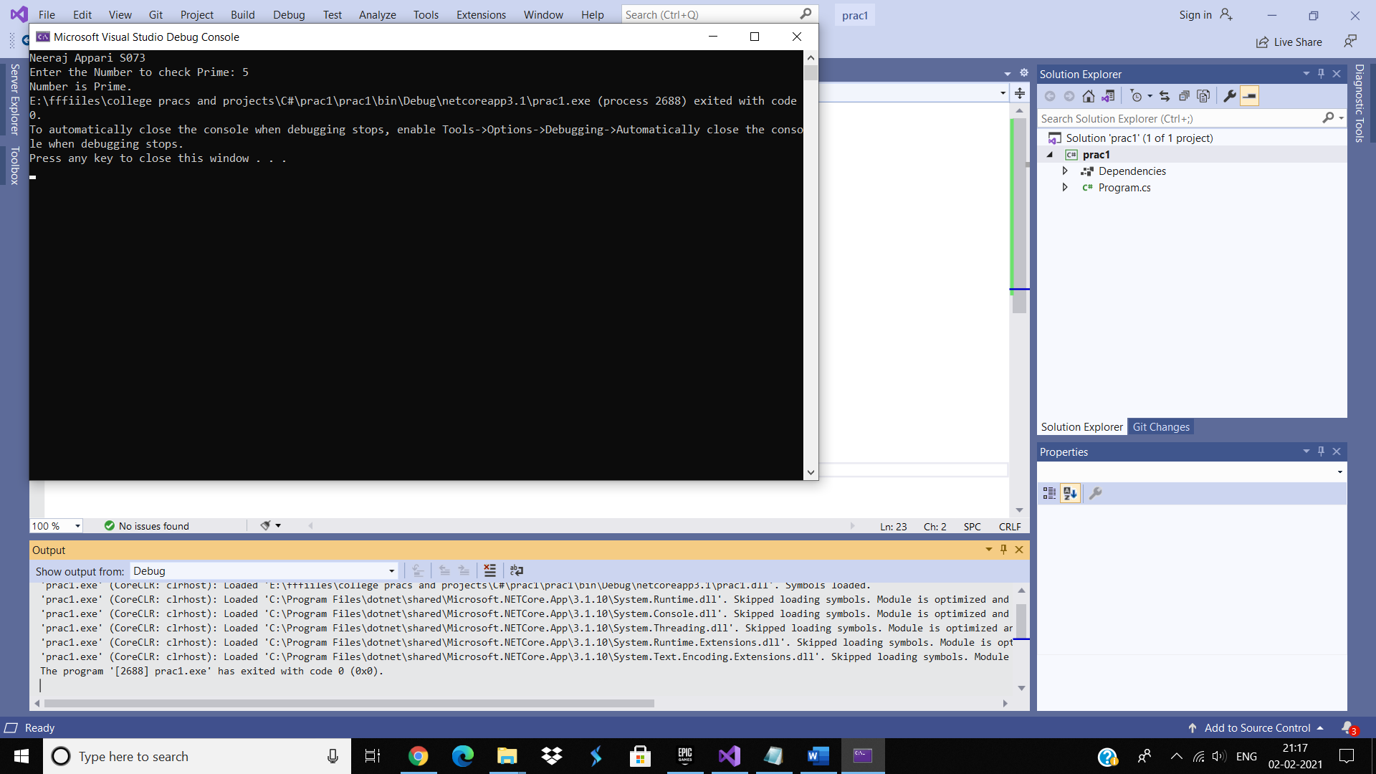

Practical-13

Aim: Write a C# program to print cube of a given number.

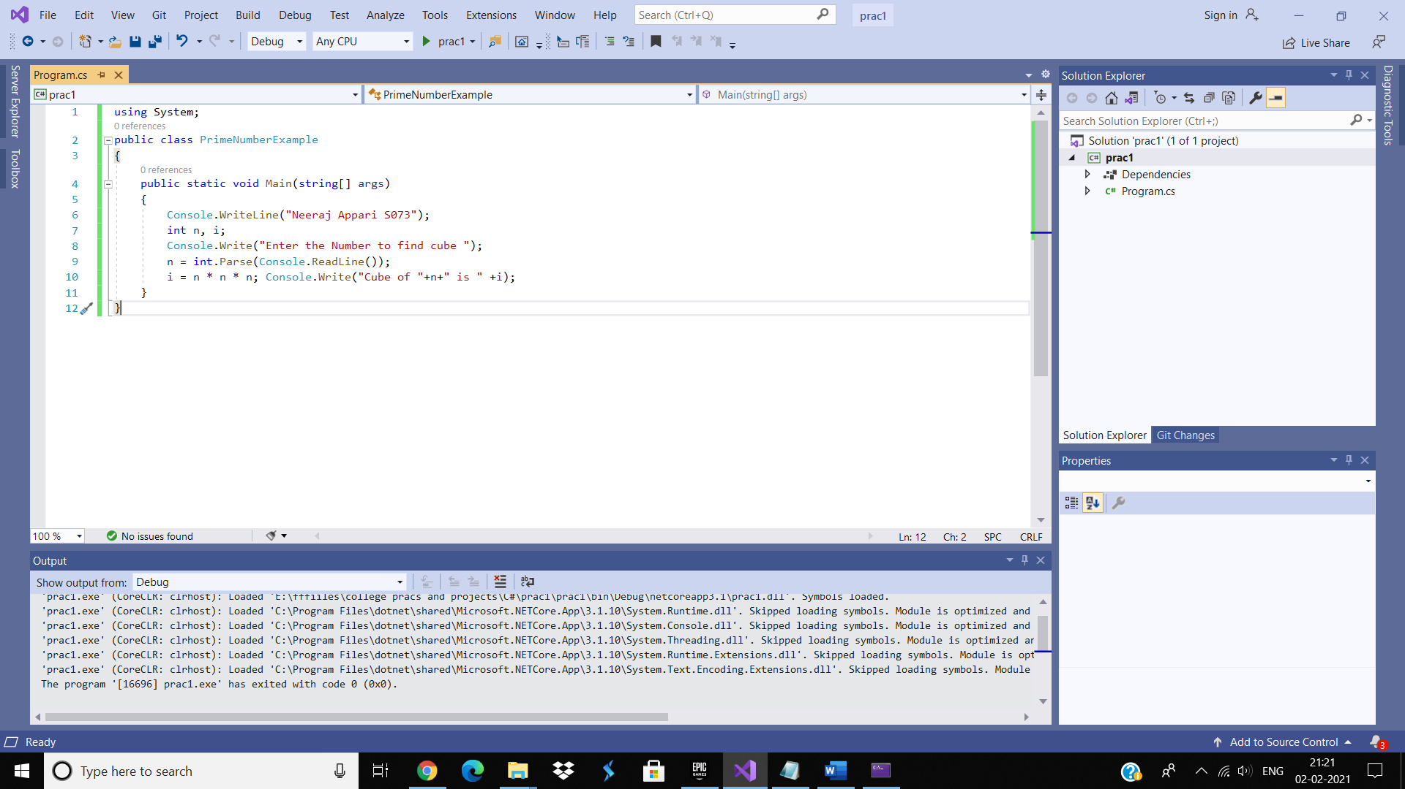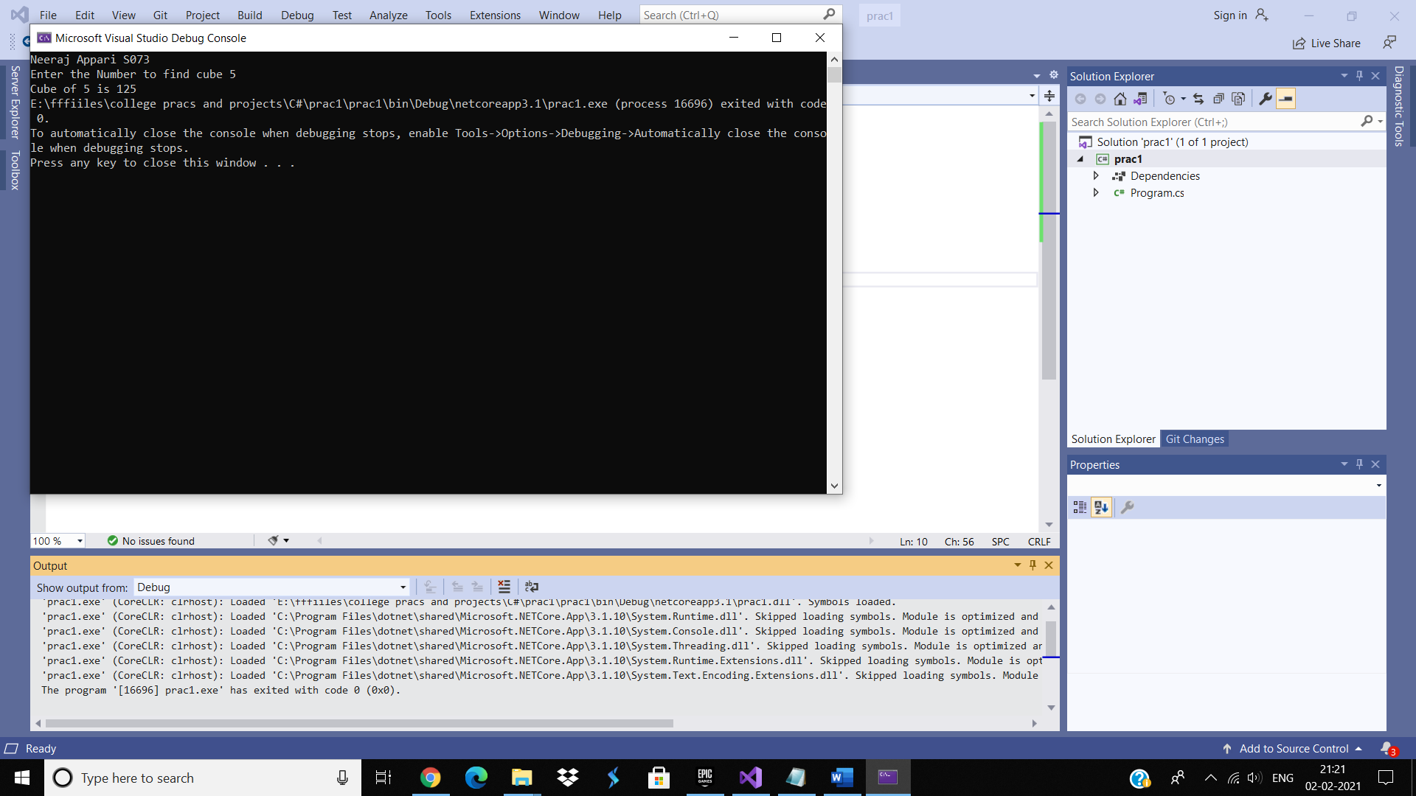

Practical-14

Aim: Write a C# program to print Fibonacci series. (recursion)

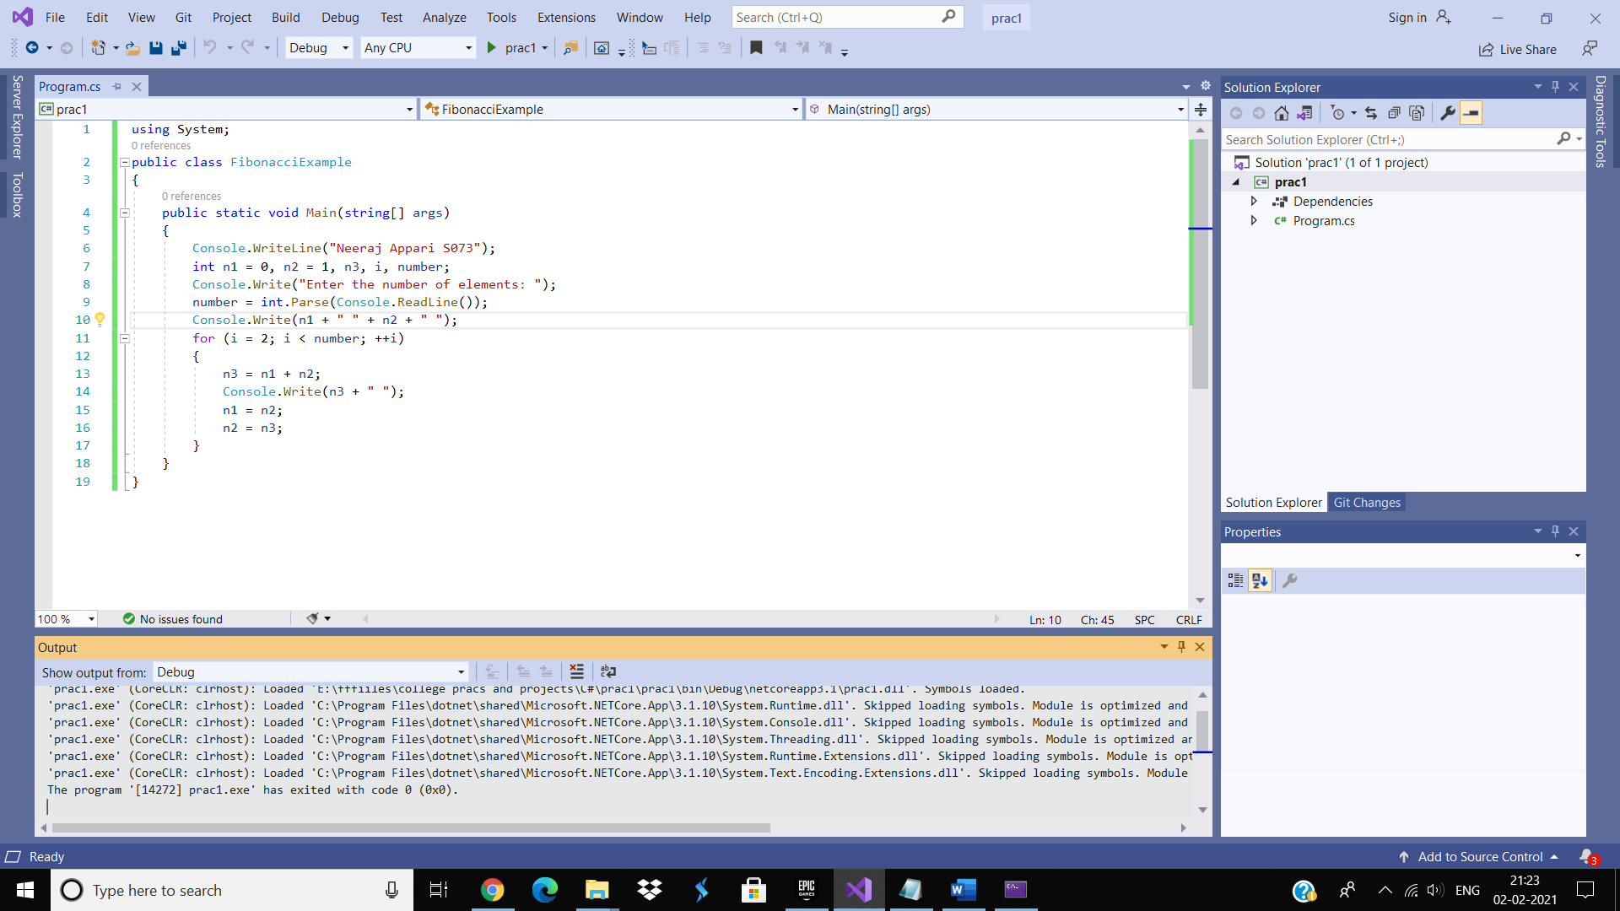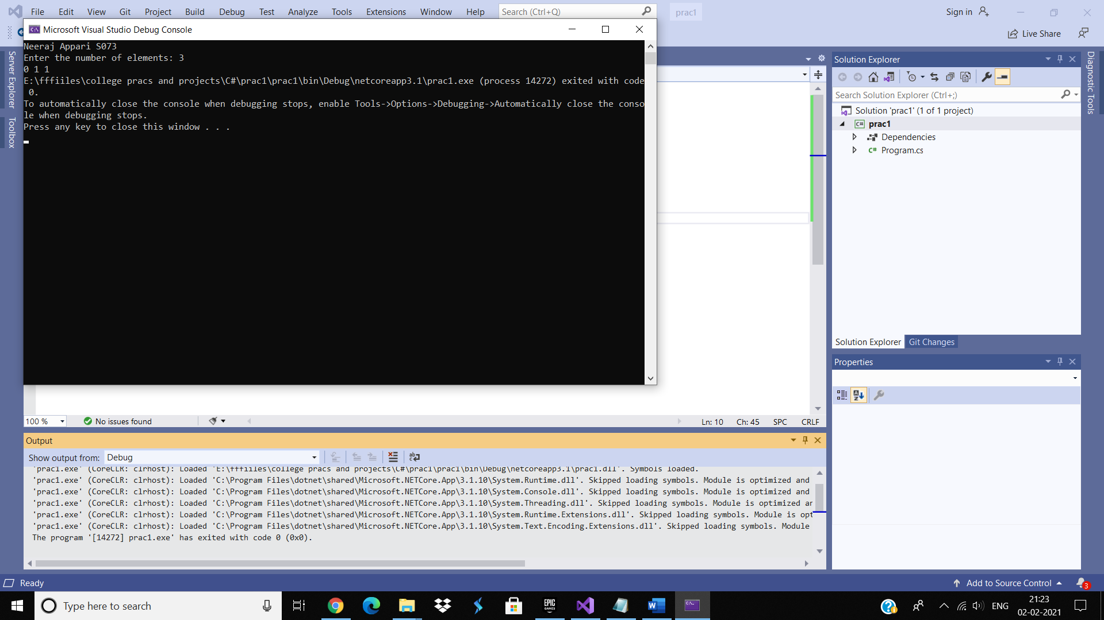

Practical-15

Aim: Write a C# program to display all even nos. from 1 to N.

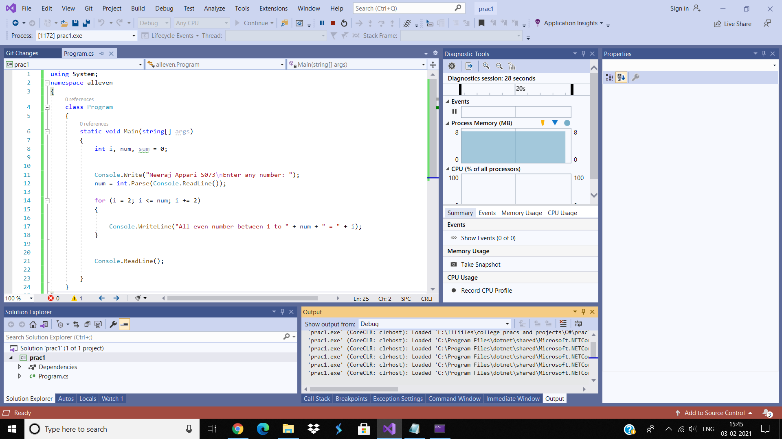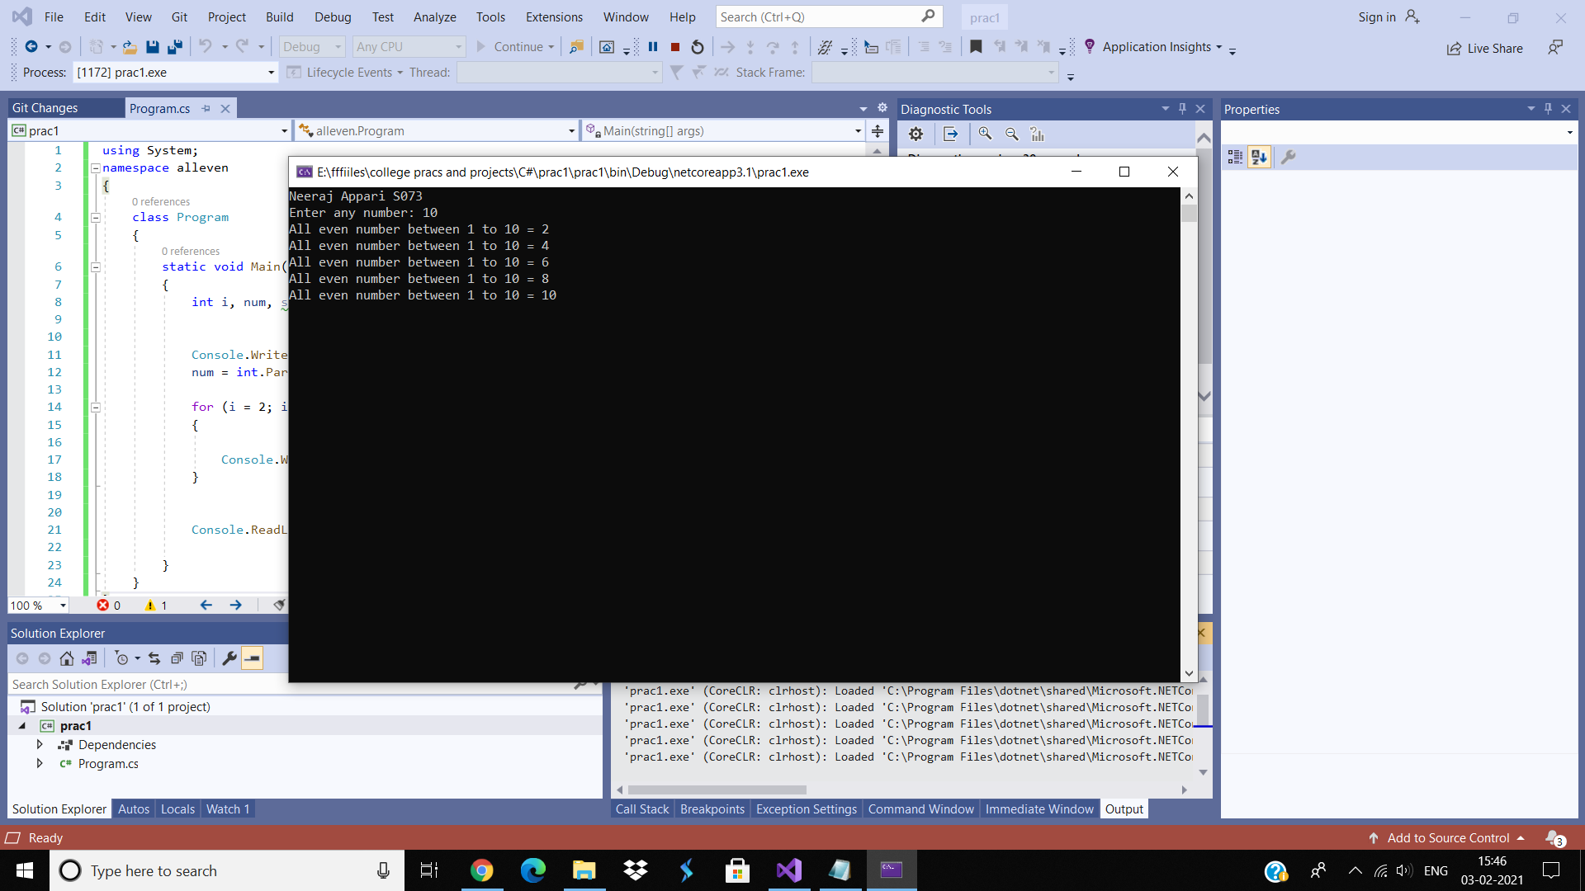

Practical-16

Aim: Write a C# program to print 1 to 10 numbers.

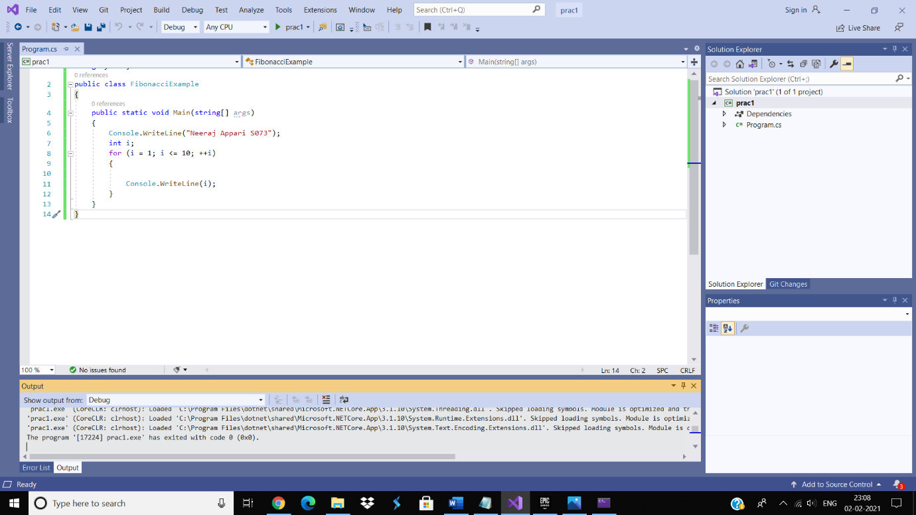

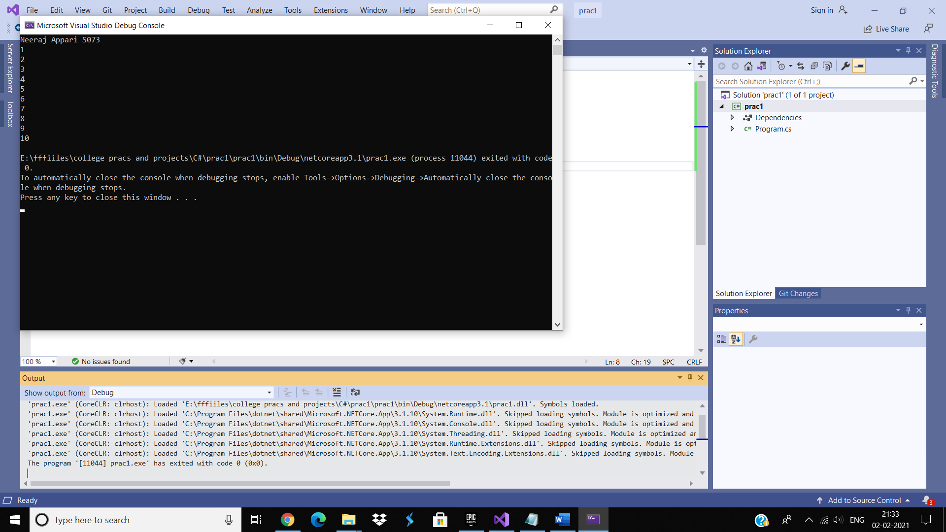

Practical-17

Aim: Write a C# program to find area of a circle. (using const double pi=3.14) 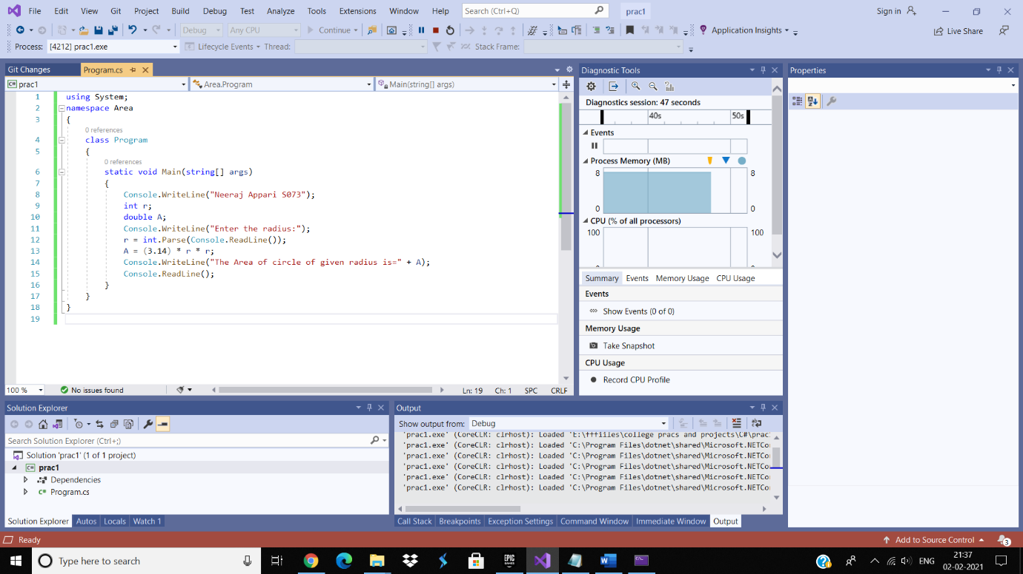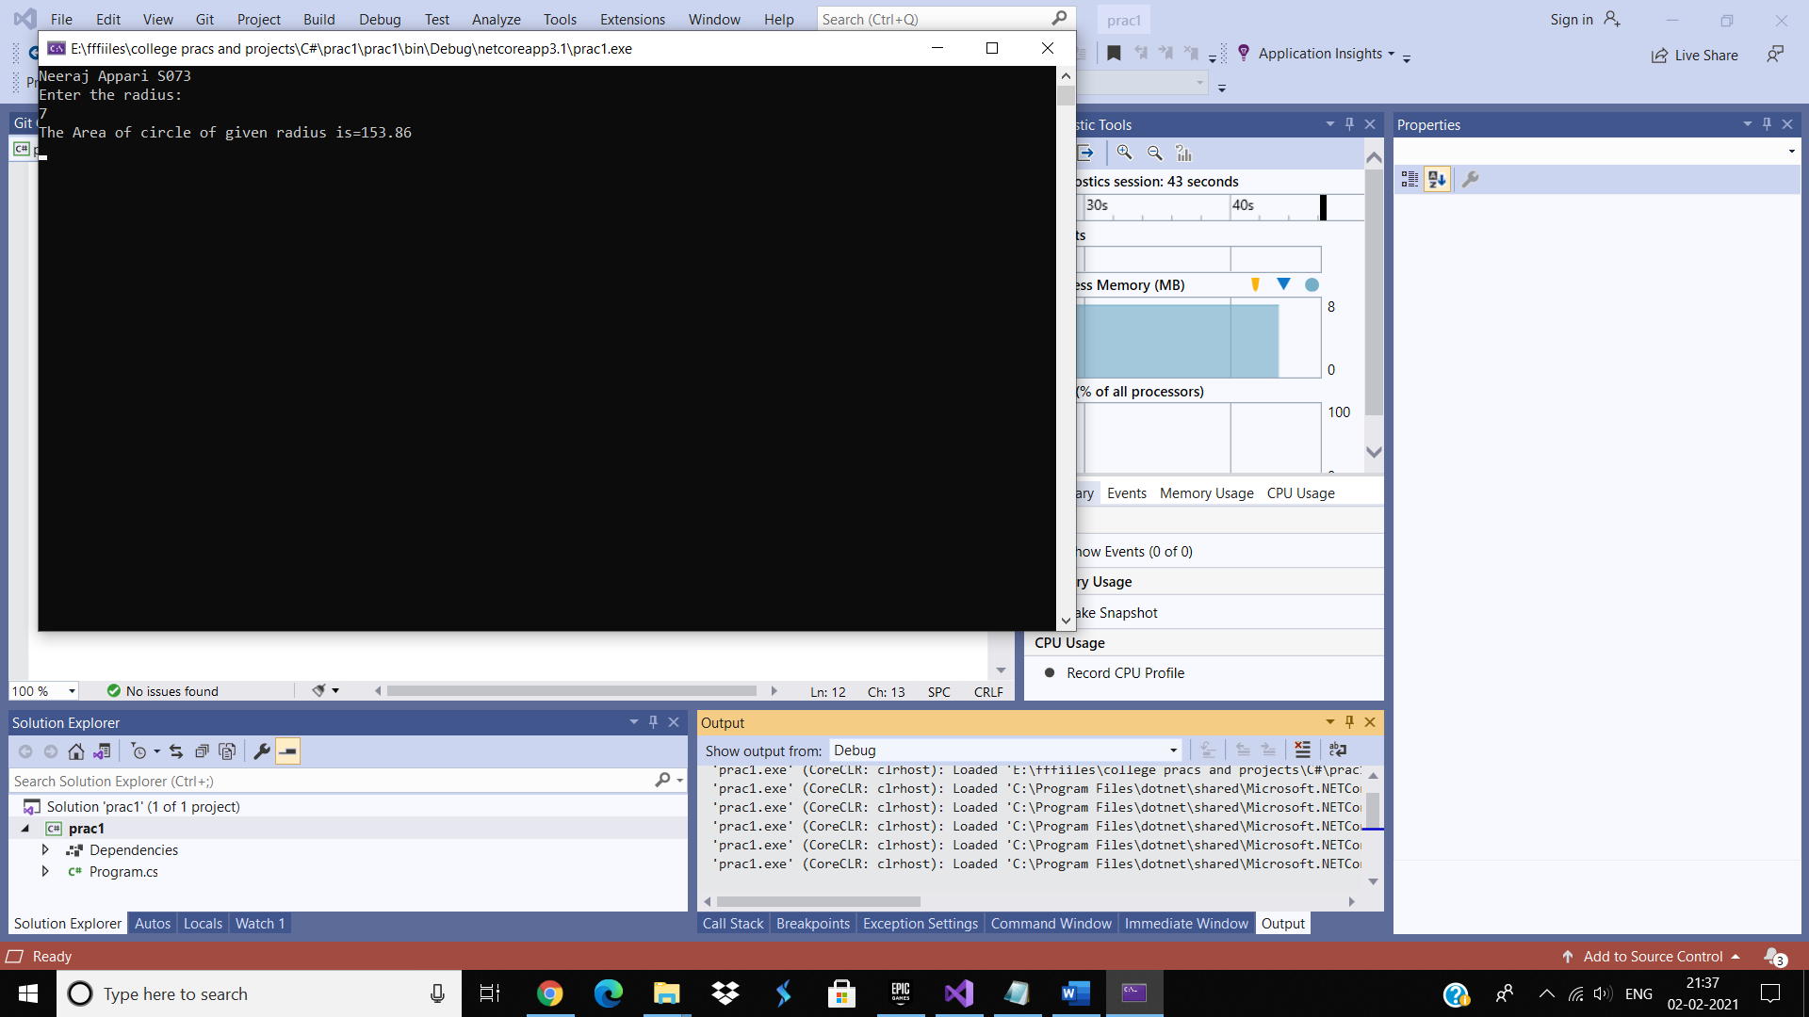

Practical-18

Aim: Write a C# program to enter marks of five subjects Physics, Chemistry, Biology, Mathematics and Computer. Calculate percentage and grade according to following conditions: Percentage >= 90% : Grade A

Percentage >= 80% : Grade B

Percentage >= 70% : Grade C

Percentage >= 60% : Grade D

Percentage >= 40% : Grade E

Percentage < 40% : Grade F

